Improving Foster Care Outcomes for Children in West Virginia

Simon Hakim, Ph.D.[1]

Ryan Hanlon, Ph.D.[2]

Brian Meehan, Ph.D.[3]

## **Introduction**

The foster care system in the United States serves as a critical safety net for children who have experienced abuse, neglect, or abandonment. In particular, West Virginia in desperately needs a well-functioning foster care system, as the proportion of children in foster care is significantly higher than national and regional averages. As shown in Figure 1, West Virginia has a higher rate of children in foster care per 100,000 children compared to the national and regional averages, with the neighboring states of Ohio and Kentucky highlighted for comparison.

Between 2013 and 2019, West Virginia experienced a near doubling in this rate, coinciding with the onset and peak of the opioid crisis.[4] This increase was not as dramatic in neighboring states nor observed nationwide. The comparatively lower fatal overdose rates in these states suggest that the opioid crisis had a less severe impact than in West Virginia.

Increases in opioid abuse can contribute to higher rates of child neglect and abandonment. In 2016, parental substance abuse was a factor in 47 percent of West Virginia foster care placements.[5] In recent years, the estimated rate of neonatal abstinence syndrome (NAS) has increased significantly nationwide, with a national average of 6.2 children with NAS per 1,000 newborn hospitalizations; unfortunately, West Virginia ranks worst in the nation, with an average of 40.8 per 1,000 newborn hospitalizations.[6] Changes in these indicators of opioid abuse are highly correlated with increases in the foster care population in West Virginia.

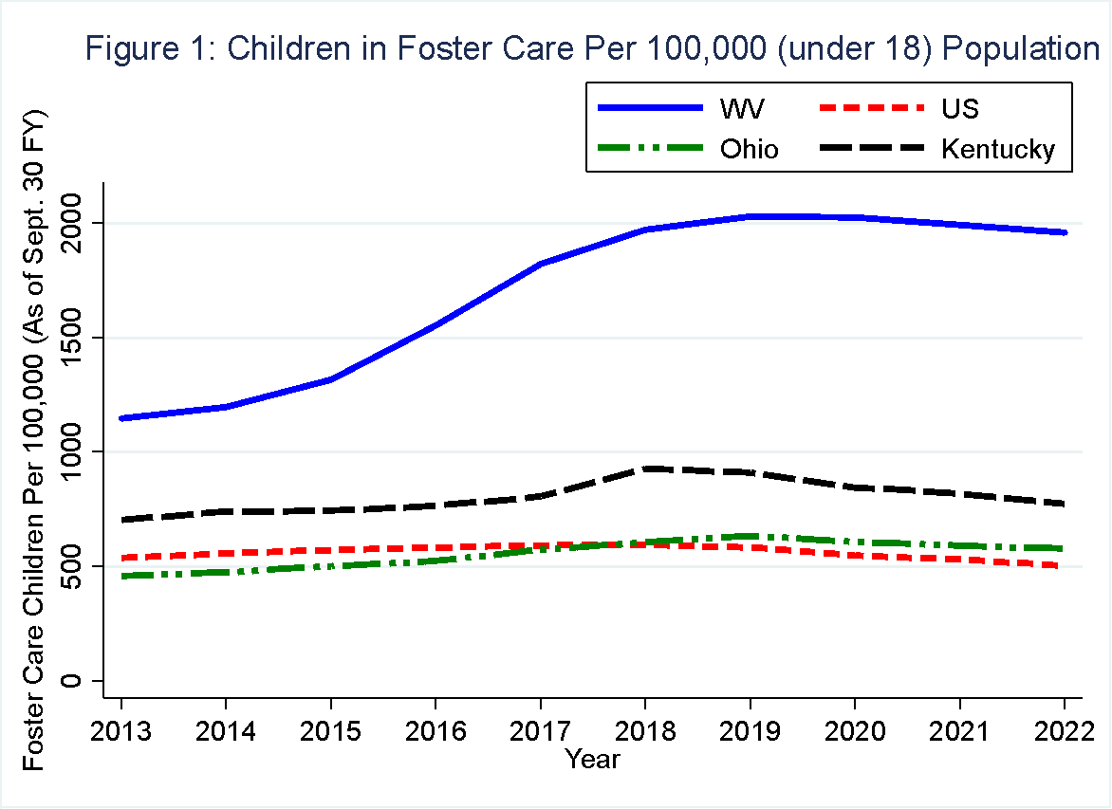

Unfortunately, long-term outcomes for youth who age out of foster care without permanent family placements tend to be poorer than those of children who are adopted or reunited with their birth parents. Linder and Hanlon’s (2023) comprehensive review of the literature indicate that children adopted from foster care experience substantially better outcomes across multiple dimensions—educational attainment, economic stability, and housing security—compared to their peers who age out of the system. Adopted children are more likely to complete higher levels of education and secure stable employment over their lifetimes. Furthermore, McMillen et al. (2005) found that rates of psychiatric disorders were significantly higher among youth aging out of foster care compared to those in adoptive placements, highlighting the critical role of permanency in fostering emotional and mental well-being.[7]

The most recent round of Child and Family Services Reviews (CFSRs)—conducted in all 50 states and the District of Columbia between 2015 and 2018, showed that West Virginia failed to substantially conform in the seven outcome domains about safety, permanency, and well-being.[8] Higher rates of adoption from foster care could decrease the prevalence of these educational, economic, and mental health deficiencies. On the bright side for West Virginia, as shown in Figure 2, adoption rates tend to be higher than regional and national averages and have been consistently rising comparing to the national and the two bordering states. (See Figure 2 which shows adoption as a percentage of total exits from foster care, where other types of exits include aging out and emancipation).

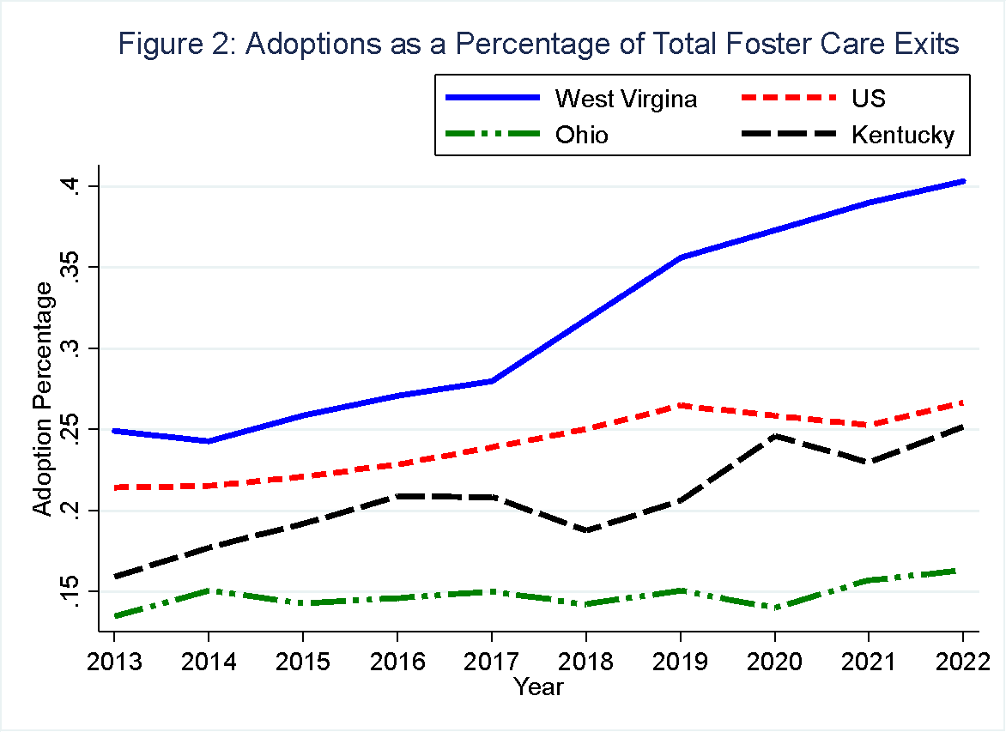

Providing a more stable foster care environment can also improve some of these outcomes.[9] West Virginia excels in stability, including placement stability, ranking first among states with the fewest moves per 1,000 days in foster care.[10] West Virginia also ranked second among all states for the fewest incidences of maltreatment within foster care.[11]

West Virginia’s relatively high rate of children entering foster care appears to be outpacing adoption and reunification efforts, leading to a crowding issue within foster care homes. As indicated in Table 1, the number of children per licensed foster care home in West Virginia is higher than in the neighboring two states (with U.S. averages unavailable for this statistic), even during the 2019-2022 period when adoption rates were at their highest in the state. This overcrowding within existing foster care homes presents potential challenges for the well-being and development of children in care.

|  |  |
| --- | --- |
| Table 1: Average Children Per Foster Care Home (2019–2022) | |
| State | **Children Per Foster Home** |
| West Virginia | 2.236 |
| Ohio | 1.998 |
| Kentucky | 1.606 |
| Notes: The table presents the average number of children per licensed foster care home from 2019 to 2022 across selected states. | |

These concerns were highlighted in a 2019 class-action lawsuit filed by a group of foster children against the West Virginia Department of Health and Human Resources (DHHR). The lawsuit accuses the department of, among other things:

*Defendants [DHHR] fail to maintain an adequate number of appropriate placements for  
youth entering foster care in West Virginia…..West Virginia’s foster care system is so overwhelmed, and there is such an acute shortage of adequate foster home placements, that DHHR has segregated children in institutions, lodged children in temporary shelter care well past the standard time frames, refrained from removing children from known abusive or neglectful homes, temporarily housed children in overcrowded general foster care homes, or placed children in poorly screened kinship foster homes.[12]* (pg. 3 and 4)

Resolving this lawsuit is of foremost importance for West Virginia child welfare officials.[13] The issues involved in West Virginia’s lawsuit will be very familiar to West Virginia’s new Governor, Patrick Morrisey, who previously served as the state’s Attorney General. Focusing efforts for the state to be released from the lawsuit and accompanying oversight will save West Virginia significant legal expenses, allowing for more resources in child welfare service provision. Officials from West Virginia’s DHHR have already made significant improvements by prioritizing the requirements of the agreement with the U.S. Department of Justice.[14] By fulfilling these requirements and prioritizing the end of federal oversight, West Virginia will have more capacity to restructure their system in a manner that supports children and families.

Given the overcrowded foster care system in West Virginia and the disparities in outcomes between adopted children and those who remain in foster care, we present recommendations for policies that promote adoption to alleviate crowding and improve outcomes for affected children. Additionally, expanding permanency planning and mental health support for children in foster care can provide crucial stability and improve long-term outcomes.

## **Policy Recommendations**

This section outlines a set of policy prescriptions to enhance the well-being of children in foster care and facilitate more successful transitions to permanent homes.

1. **Workforce Recruitment and Development**

Nationally, the child welfare workforce is short-staffed and underdeveloped, with high rates of turnover year after year.[15] West Virginia is no exception, and this barrier was noted in the state’s most recent Program Improvement Plan (PIP), “The constant churning of staff stresses the Department’s limited fiscal resources….”[16] In the short term, West Virginia child welfare officials can work to over-recruit for vacancies, recognizing that there is a high turnover rate and that being understaffed leads to high caseloads, which burn out staff and lead to poor service provision to children and families. These service issues can lead to less successful adoptions and reunifications.

In developing the workforce over the long term, West Virginia can look to implement apprenticeship programs that lead to credentialing and training undergraduate students, allowing these students to gain experience that would benefit future employment while earning academic credit. These relationships can naturally lead toward easier hiring of the better experienced workers to where their training took place, and to attract students to join these academic programs.

Recently, public-private partnerships in medical services have been used to improve labor supply pipeline issues in medicine. Allowing private entities to have a more active role in foster care services could expand these services and allow competition in quality and pricing. This could help relieve the state government from its current shortage in staffing professional social service workers and awarding them job security. Such Public-Private Partnerships (P3s) have proved successful in many areas of medical care. For example, Thomas Jefferson Medical University in Philadelphia, along with five other universities, collaborates with the pharmaceutical and healthcare industries to provide students with real-world experience and career opportunities. Students complete their first year in graduate school, followed, in the second year by industry-based training, with courses taught in the first year by professionals and potential job placement (Shah et al, 2025).[17] Many students in the programs are indeed hired where they train. Also, the medical companies involved provide fellowships to attract students to the program.

The child welfare field faces a persistent shortage of social service workers, despite government funding. A similar P3 approach—partnering universities with foster care or social service agencies—could offer specialized education and hands-on training, increasing the number and quality of social workers. If government funding were extended equally to public and private providers, competition could drive the creation of fellowships and training programs, attracting more students, reducing the workload of service providers, and improving workforce readiness.

On January 4th, 2025, President Biden signed into law the Protecting America’s Children by Strengthening Families Act,[18] finalizing a bipartisan commitment to reauthorizing Title IV-B funding, including additional funding beginning in fiscal year 2026 to support child welfare workforce. This legislation allows states to use workforce funding to increase retention, provide training, and support caseworkers’ needs. This increase marks an opportunity for West Virginia to manage the workforce crisis – by investing in staff development. Allowing authorized private and public social workers to become eligible for this funding could increase competition in the industry and improve the quality and quantity of service providers.

1. **Foster Parent Recruitment and Retention**

West Virginia is not alone in its struggle to maintain enough trained and equipped foster parents. Putting in place a strategic plan to recruit and retain foster parents can go a long way in addressing this problem. While broad outreach to the community can be an effective way to reach a wider audience, foster parents are often successfully recruited after having a direct connection to the child welfare system. It is common for foster parents to have been introduced through relatives, friends, or neighbors. Examples of targeted recruitment include faith-based communities, special needs support groups, LGBT+ community groups, and existing foster and adoptive parent support networks.

The most effective recruitment source is existing foster parents themselves. Foster parents often begin as respite caregivers, wraparound support providers to those in their neighborhood or faith community, before providing direct service as foster parents.[19] Agencies should consider recruiting for support/ancillary services (e.g., wraparound care) and develop these workers to additional service levels. In a systematic review of the literature,[20] the five primary factors affecting foster parent retention researchers identified were:

• Relationship to the child welfare system (including caseworkers)

• Material resources (e.g., reimbursements, services, etc.)

• Personal attributes (e.g., confidence, personal agency, etc.)

• Training (pre-service and ongoing)

• Peer support (social, emotional, and shared knowledge)

1. **Review of Foster Care Licensing Requirements**

Reducing barriers to licensure would expand the number of qualified homes. While some requirements for safety are well-founded in safety concerns (e.g., having at least one operating fire alarm),[21] many other restrictions seem overly burdensome and may prevent otherwise great foster home providers from being licensed. We recommend a review of the entire licensure process, utilizing a Delphi review[22] conducted by experienced, qualified child welfare professionals and foster parents. For example, rules six, eight, and thirty-one of the West Virginia’s requirements, which are listed in the Appendix, may not be significant safety concerns and, therefore, serve as barriers to otherwise qualified candidates.[23]

Offering more flexibility in meeting licensing requirements should be seriously considered, seeking to maintain safety while not excluding safe families and homes. Once rigid and very detailed requirements are published, the inspector of the home and the prospect provider have limited flexibility in allowing the unfulfillment of even a minor requirement. We believe that more general requirements on major items should be published, allowing the inspector to use his/her judgment on the appropriateness of the prospect provider. The limited scope of this project precludes us from making specific recommendations. The training of the inspectors and the findings of the Delphi procedure could include the distinction between essential and less important items, allowing them to use their professional judgment in each case they examine without being forced by the published rigid and detailed requirements. This will also allow flexibility depending on the current need for foster care homes.

Reducing licensing requirements could increase the number of foster parents and prevent the use of alternative pathways for foster care children, like large group homes and mental health institutions.

1. **Invest in Youth Mental Health Care**

The challenges faced by states to meet the high-acuity needs of older foster youth are exacerbated by a lack of service providers. West Virginia lacks sufficient youth mental health care, resulting in children being sent out of the state.[24] With an insufficient workforce and too few licensed foster parents, children with significant mental healthcare needs are often unable to maintain an appropriate placement.

Federal programs with The US Department of Health and Human Services Children’s Bureau exist to help equip the child welfare workforce and teachers with the knowledge and skill sets to address mental health needs.[25],[26] These training programs are provided without charge, and resources require West Virginia child welfare officials to dedicate valuable staff time to these training sessions. These programs alone will also not be sufficient to meet the needs of youth in care. West Virginia lacks a sufficient number of child psychiatrists and other mental health service providers, leading to long wait times or no services available to foster youth with urgent need of care.[27]

One policy change that could bolster the number of mental health professionals is state-level licensing reciprocity for medical professionals. Medical professionals who are licensed in other states should be allowed to practice in West Virginia without requiring them to undergo a new set of state-level requirements. Oh and Kleiner (2025) show that universal licensing recognition among physicians improved healthcare access and utilization and led to an inflow of doctors to states that passed this licensing recognition.[28] Universal licensing recognition for mental health professionals could help to attract more of them to West Virginia. If someone is a licensed child psychologist in any other state, allow those licensed psychologists to transfer that license to West Virginia.

## **Conclusion**

Some of the challenges West Virginia faces, such as shortages in social service workers and qualified foster parents, are problems many other states are trying to address. In addition to these, West Virginia faces unique and acute issues due to the opioid crisis’s direct impact on the child welfare system. By first addressing and relieving the burdens imposed by the federal lawsuit, West Virginia officials will have increased capacity to implement policy changes and invest in the workforce and other resources necessary to achieve the safety and permanency goals for the children in their state. We highlight strategies to address these issues. Broadly, these include recruiting and developing a qualified child welfare workforce by developing P3 specialized training graduate programs in local universities, allowing private companies to provide foster care services by enabling them to enjoy the same support that public agencies receive, increasing and retaining quality foster care parents and foster care homes, and addressing shortages in mental health services for foster care children. Our policy recommendations include directing federal resources to workforce development, and licensing reform for foster care and mental health providers. The requirements for foster care housing should become more general and subject to the social workers’ judgments. West Virginia could institute universal licensing recognition for mental health care professionals, which could allow qualified candidates to relocate to West Virginia without additional state-level licensing burdens. In addition, enabling Public-Private Partnerships in the training and academic education of social workers could also bolster the in-state workforce and improve quality.

We suggest revising the requirements for the licensing of foster care homes to a less restrictive and shorter list. As a follow-up study, a Delphi procedure could be employed by surveying the professional stakeholders, and deriving the significant requirements and their relative importance.

Introduction of PPP to the provision of of foster care services will lead to greater competition among the private and public providers and as a result to increase efficiency in service provision.

## **Appendix**

# Selected State-Level Foster Care Licensing Requirements

## West Virginia Health and Safety Foster Care Licensing Requirements[29]:

West Virginia provides detailed requirements for becoming a foster care parent. See footnote 28, section 2.3 Certification Process pages 14-19.

Prospective Foster/Adoptive Parent Eligibility Criteria

In order to become a foster/ adoptive parent, the applicant must meet the following eligibility criteria.

General

1. The applicant must be at least eighteen (18) years of age or older at the time of application.

2. Applicants must be nurturing, responsible, patient, stable, flexible, mature, healthy adults capable of meeting the individual needs of children referred for placement services.

3. A couple who wish to be foster/adoptive parents must demonstrate that

their relationship will provide an environment of stability for children.

4. The decision to become a foster/adoptive parent shall be agreed to by all members of the household, including other children in the home over the age of twelve (12).

5. The prospective foster/adoptive parent must be willing and able to accept the level of involvement and supervision provided by the Department and/or specialized foster care agency for children placed in their home.

6. The prospective foster/adoptive parent must be a United States citizen and a resident of West Virginia.

7. The prospective foster/adoptive parent may not function as a daycare provider, adult family care provider, specialized foster/adoptive parent, or any other social service provider without prior approval of the Regional Program Manager or Child Welfare Consultant.

Capacity

1. Foster/adoptive parents shall accept children for foster care only from the Department of Health and Human Resources unless they are dual providers sanctioned by the Regional Program Manager or Child Welfare Consultant under specific circumstances.

2. The number of children placed in a home shall be determined by the stamina, capacities, skills of the parents, physical accommodations of the home, and the effect of a child’s placement on the equilibrium of the family as a unit. No more than six (6) children, including the foster children, and the foster/adoptive parents’ own children, or any other children under the age of eighteen (18) living at home shall reside in the foster home at any given time. The only exception may be for the placement of a sibling group with the prior approval of the Homefinding Supervisor who will then notify the Regional Program Manager or Child Welfare Consultant by the next working day.

3. Waivers can be issued for the number of children in the homes under the following circumstances:

1) to allow a parenting youth in foster care to remain with the child of the parenting youth;

2) to allow siblings to remain together;

3) to allow a child with an established meaningful relationship with the family to remain with the family; and

4) to allow a family with special training or skills to provide care to a child who has a severe disability.

4. No more than two (2) children under the age of two (2) are to be placed in a foster home at the same time.

5. No more than two (2) children who are medically fragile or non-ambulatory shall reside in a foster home at the same time.

Home Safety Environment

1. The use of mobile homes will be limited to those manufactured after 1976. In addition, all mobile homes must be equipped with push out window frames that are the type of sash/windows that rise up and can be used as an emergency exit.

2. All homes must have screens on all windows that open and have at least two exits that can be used for emergency exits.

3. A battery operated smoke alarm must be located near each bedroom and in the kitchen area.

4. The house must be equipped with a battery-operated carbon monoxide detector, unless everything in the home is generated by electricity.

5. A useable portable five (5) lb. or larger ABC Certified fire extinguisher must be located in or near the kitchen of the home.

6. An operative flashlight must be easily accessible for emergency lighting.

7. A home diagram must be made identifying rooms and occupants that reflects a fire escape plan, escape route, and an outside meeting place.

8. Each child must be taken through the fire escape route within twenty-four (24) hours of placement.

9. If the child’s bedroom is located on an upper floor of the house, it must have a fire escape ladder available for emergency exits.

10. If a garage is attached to the house, it must be separated from the house by a tight fitting door which is kept closed, when necessary, to prevent exhaust fumes from entering the home.

11. The home must be in good repair and free from any visible dangers to children. (This includes the walls, ceilings, floors, stairs, wiring fixtures, plumbing fixtures, porches, appliances, etc.

12. Furniture, carpets and accessories shall be sanitary, in good condition, comfortable and free from odors.

13. Heat sources such as fireplaces, furnaces, stoves, radiators, water heaters, and other heaters must have safeguards including thermostatic controls, automatic shut off valves, vents, and screens that are functioning, when required on the heat source.

14. Walls, ceilings and floors, must be adequately protected from heating and cooking equipment by sufficient clearance or noncombustible insulation. Areas near the chimney, furnace, water heater and stove must be free from items that could catch fire.

15. Ashes from burning coal or wood must be kept in a metal container clear of wood floors and walls. The exhaust pipes for wood stoves, fireplaces and coal-burning stoves must be maintained to keep them free of creosote.

16. Makeshift heating or cooking devices such as charcoal grills, camping stoves, kerosene heaters, etc. which could cause carbon monoxide poisoning or other accidents may not be used indoors.

17. Extension cords must be used properly.

18. Electrical circuits must be protected by a maximum twenty (20) amp fuse or circuit breaker.

19. All household items that may be hazardous to a child must be stored in unbreakable, clearly labeled containers out of the reach of children. This includes household cleaning supplies, gasoline, pesticides, weed killers, etc. Medicines will be stored in areas that are inaccessible to children. Alcoholic beverages should be properly placed out of the reach of children who do not have the capacity to understand the difference between alcohol and appropriate beverages, to avoid accidental ingestion.

20. All weapons must be kept properly stored in a locked container inaccessible to children, preferably one made out of solid wood or metal. If a glass case is utilized to store firearms, trigger locks must be used on all firearms. Ammunition and all other weapons including knives, throwing stars, etc. shall also be stored in a separate locked container out of reach of children. The following are considered weapons: firearms, air guns, BB guns, Hunting slingshots, and any other projectile weapon;

21.All ammunition, arrows or projectiles for these weapons must be stored in a locked space separate from the weapons;

22. Foster/Adoptive Parents who are law enforcement, may be exempt from these requirements if the can:

23. Provide documentation of their jurisdiction’s requirement to have their weapon ready and immediately accessible at all times;

24. Adopt and follow a safety plan that is approved by the agency.

25. The home must have an appropriate supply of water, including an adequate supply of hot water to sanitize cooking and eating utensils.

26. If drinking water is supplied by means other than a municipal water supply, it must be evaluated and approved safe by the local Department/Division of Health or by an objective, independent facility capable of making such distinctions.

27. Liquid waste shall be disposed of in a sanitary manner into a septic system. Septic systems must appear to be in good working order with no standing ground water that appears to be leaking from the system or no strong odor of sewage around the home. If there appears to be a sewage or septic problem, the system should be checked.

28. Garbage and trash shall be collected and disposed of in compliance with established standards of the Department‘s Division of Health.

29. All pets kept at the home must have proof of vaccination/certification which is required by West Virginia Code §19-20A-2. If the animal is sickly or vicious, it must be confined in an area not accessible to children. Children will be instructed in the proper care methods before they are allowed to handle or care for an animal. All children must be carefully supervised when handling or caring for an animal.

30. The home must have a working telephone for communication in case of an emergency.

31. Decks and porches eighteen inches (18") from the ground or higher must have appropriate enclosures/railing around the parameter of the deck to keep a child from falling from the deck/porch. The area below the deck must be enclosed with wire mesh or wood lattice, unless there is useable living space below the deck.

32. If the home has an in-ground or stationary above-ground pool, it must be enclosed by a fence that has a locking gate, door and/or ladder to prevent unsupervised access to the pool by children. If the home has a decorative pond or kiddy/wading/blow-up type pool the family must take measures to prevent unsupervised access to the pond/pool by the children.

Bathrooms/Bedrooms

1. Bathrooms must have windows and/or fans for ventilation.

2. Bathrooms shall be easily accessible and equipped to meet the needs of the foster child placed in the home.

3. Bathrooms shall be clean and toilet and bathing facilities shall be free from odors and in good working order.

4. Bathrooms must have doors for privacy.

5. Children shall not be housed in unapproved rooms or detached buildings.

6. Each individual bedroom must have a window to the outside and a door.

7. Attic or basement bedrooms must meet the same standards as all bedrooms in the home.

8. A child’s bedroom must not be used for any other purpose by any other member of the household. The home shall have enough bedrooms to allow sufficient living space without disrupting the living arrangements of the family. *Rooms not designated as bedrooms shall not be used for sleeping purposes on a continuous basis.

9. No more than four (4) children, including the foster/adoptive parents own children, may share a bedroom. All children sharing a bedroom will be of the same sex.

10. Each child shall have his own bed with appropriate mattresses and linens. All children, except for children under two (2) years of age, must have space for their personal possessions and a reasonable degree of privacy.

11. Folding cots, roll-away beds, inflatable mattresses, or mattresses on the floor are not permitted. In an emergency, a waiver may be requested through the Homefinding Specialist and will be time limited.

12. The bedroom of an individual with a physical disability shall be within easy access of a responsible person who can provide care when needed. In some instances, the individual child’s bedroom may need to be located on the ground level and/or the same floor as the bathroom.

13. Each infant shall have a crib that meets federal standards for sleeping. At no  time will infants share a bed with an adult; they must have their own crib.       Foster parents will receive instruction on Safe Sleep during in-service training.

14. Adults should not share a bedroom with a child. Exceptions may be made for children under the age of two (2) years or for children who are medically fragile.

Although you must be able to meet the financial needs of your family, you do not need to have a lot of money. You don’t need to own your own home, have children already, or be a stay-at home parent to foster/adopt. Most adoptions from foster care are free and any minimal costs associated with them are often reimbursable. In addition, there are different types of postadoption resources, such as medical assistance and financial adoption assistance, based on the specific needs of a child, to help support and sustain adoptions from the foster care system.

Families of all shapes and sizes foster and adopt. You can be married, single, divorced, or cohabiting. There is no “perfect” type of foster or adoptive family— all types of families are needed for all types of kids.

## Kentucky Health and Safety Foster Care Licensing Requirements[30]:

* Age: Be at least 21 years old
* Residence: Live in Kentucky
* Transportation: Have a valid driver's license and reliable transportation
* Income: Have sufficient income to meet the needs of your family
* Background check: Pass a criminal background check, child abuse and neglect background check, and drug screen
* Home inspection: Pass a home inspection to ensure your home is safe, secure, and healthy for a child

Also,

* Interested families must attend an informational meeting
* Parents can be married or single
* Parents should be financially stable and have an income (separate from any financial support offered to foster or adoptive parents for the child's needs) sufficient to meet their family's needs
* Applicants must be able to provide a safe, secure, and healthy home for a child
* Parents must be in good physical and mental health
* The home must meet requirements for housing safety and space

Can be married, single, or divorced.  
 - May or may not have children.  
 - Can own or rent your home/apartment.  
 - Be 25 years of age, or if a two-parent home, at least one applicant must be 25. (Before, the age of 21 was stated.)  
 - Must be a citizen or legal permanent resident of the United States.  
 - All applicants in the home must be able to attend agency training.  
 - Valid state driver’s license, with reliable transportation.  
 - Have a physical completed by your primary care physician.  
 - Pass all background checks along with drug screening.  
 - Home must have a bedroom to accommodate a foster child/children.

All adults in the home must successfully complete training requirements, which include an informational meeting, 15 hours of preparation training and web-based trainings. In addition to the training, all adults will complete paperwork to help them make an informed decision about whether fostering and adopting is appropriate for their family. The training, evaluation and approval process normally takes six to nine months. The amount of time until a family receives a child depends on how flexible the family is about the type of child they wish to parent. Foster parents may receive a child shortly after approval. Adoptive placements generally take longer because the move to an adoptive home must be planned and gradual so that both the child and the family have time to adjust.

You may be disqualified from becoming a foster parent if:

* You or a family member have a felony conviction for sexual violence, death, or involving a child or spouse
* You or a family member have a physical or mental health condition that would prevent you from providing proper care for a child
* You don't have adequate income

## Ohio Health and Safety Foster Care Licensing Requirements[31]:

1. The home and all structures associated with the home are maintained in a clean, safe, and sanitary condition and in a reasonable state of repair.

2. Swimming pool on foster home property has barriers on all sides, access through the safety barrier equipped with a safety device such as a bolt lock, a lifesaving device such as a ring buoy and a working pump if it cannot be emptied after each use.  
  
 3. Hot tub and spas on foster home property have a safety cover which is locked when not in use.

4. Outdoor recreation equipment on the grounds of the foster home is maintained in a safe state of repair.

5. Potentially hazardous outdoor areas on the grounds of or immediately adjacent to the foster home are reasonably safeguarded.

6. The home is adequately heated, lighted and ventilated.

7. Bleach, cleaning materials, other poisonous or corrosive household chemicals, flammable and combustible materials, potentially dangerous tools/utensils, and electrical equipment, machinery or alcoholic beverages in or on the grounds of the foster home are stored in a safe manner preventing the child's access, as appropriate for his or her age and development.  
  
8. Firearm, air rifles, hunting slingshot or other projectile weapons kept on the grounds of or in the foster home are stored in an inoperative condition in a locked area inaccessible to children.

9. Ammunition, arrows or projectiles for weapons are stored in a locked area in the foster home separate from the weapon.

10. There is reasonable access to a working phone for emergency situations  
  
11. Emergency telephone numbers posted in the foster home:  
 Fire Police Squad/Rescue Poison Control Recommending Agency Placing Agency.

12. All locks on at least one door to any room or walk in storage area inside the foster home in which a person could become confined, and from which the only other means of exit requires the use of a key, shall be able to be unlocked from either side.

13. The home has a continuous supply of safe drinking water. If well water is used for drinking and cooking, it was tested and approved by the health department prior to initial certification or approval (and annually thereafter for foster care).

14. The foster home has working bathroom and toilet facilities located within the home and connected to an indoor plumbing system.

15. The foster home ensures a proper water heater temperature not to exceed 120 degrees Fahrenheit.

16. Garbage shall be disposed of on a regular basis from the foster home. Garbage stored outside the foster home shall be in covered containers or closed bags.

17. The home has a working smoke alarm approved by "Underwriter's Laboratory" or a certified fire inspector on each level of occupancy and at least one alarm near all sleeping areas.

18. The home has a working carbon monoxide detector on each level of occupancy of the home and at least one near all sleeping areas.

19. The foster home has first aid supplies.

20. The foster home has a written evacuation plan for evacuating the home or seeking shelter in the event of fire, tornado or other disaster.

21. The evacuation plan of the foster home contains a primary and alternate escape for each floor, and the escape routes are kept free of clutter and other obstructions.

22. All heaters used in the foster home are approved by "Underwriter's Laboratory" or a certified fire inspector and are equipped with safeguards in accordance with age and functioning level of foster children in the home. Unvented heaters that burn kerosene or oil are not used.

23. The foster home has an "Underwriter's Laboratory" approved or certified fire inspector approved portable fire extinguisher in working order in or near the cooking area of the home.

24. The foster home is free from rodents and insect infestation.

25. Pets or domestic animals in or on the premises of the foster home are kept in a safe and sanitary manner in accordance with state and/or local laws.

26. Interior and exterior stairways in the foster home accessible to children are protected by child safety gates or doors according to the child’s age and functioning level.

27. The foster home provides a smoke free environment for foster children.

28. If the foster home has peeling or chipping paint, the recommending agency is to make a referral to the appropriate agency.

29. All prescription drugs in the foster home are stored in a locked cabinet or storage area except that an inhaler or medication may be left unlocked if a person has a special health condition that requires it to be immediately available.

30. Each foster child’s bedroom has an outside wall window that is screened and capable of opening and closing or the room has a fresh air ventilation system.

31. Bedrooms for foster children accommodate no more than four children.

32. Bedrooms for foster children provide reasonable access to an emergency exit.

33. Bedrooms for foster children are not located on a floor higher than the second floor or in a basement unless approved in writing by a fire safety inspector.

34. A bunk bed in use for a foster child is equipped with safety rails on the upper tier for a child under the age of ten years, or an older child who needs such protection.

35. Cribs used for foster children under two years of age or under 35 inches in height are:  
 • full-sized  
 • slats no more than 2 3/8 inches apart  
 • no decorative cutout areas on end panels which could entrap a child’s head  
 • compliant with the U.S Consumer Product Safety Commission  
 • mattress is at least 1½ inches thick and covered with a waterproof material  
 • mattress is close enough to the frame that there is no more than one inch between the mattress and sides of the crib.

36. If a bassinet is used in the foster home, it is used only for infants less than 15 lbs. in weight.

37. All vehicles used to transport foster children are covered by liability insurance in accordance with current state laws.

38. In accordance with the age and weight of foster children placed in the home, child restraint seats or booster seats are available for use in vehicles used to transport foster children.

1. Center for Competitive Government, and Department of Economics, Temple University
2. National Council for Adoption
3. Campbell School of Business, Berry College
4. See Cooper, R. L., Thompson, J., Edgerton, R., Watson, J., MacMaster, S. A., Kalliny, M., ... & Singh, K. P. (2020). Modeling dynamics of fatal opioid overdose by state and across time. *Preventive medicine reports*, *20*, 101184., which shows the dramatic increase in opioid related deaths in 2015-2016.
5. Hogan, L., Warner, L. A., Brown, M., & Strickland, C. J. (2018). *The opioid crisis and child welfare: Recent research findings.* Regional Educational Laboratory Appalachia. Retrieved from <https://ies.ed.gov/ncee/edlabs/regions/appalachia/blogs/pdf/REL-AP-WV_Poster_508.pdf>
6. Agency for Healthcare Research and Quality. *Healthcare Cost and Utilization Project (HCUP) Fast Stats*. <https://datatools.ahrq.gov/hcup-fast-stats/?tab=special-emphasis&dash=83>
7. McMillen, J. C., Zima, B., Auslander, W., Scott, L., Munson, M. R., Ollie, M., & Spitznagel, E. (2005). Prevalence of psychiatric disorders among older youths in the foster care system. *Journal of the American Academy of Child and Adolescent Psychiatry*
8. Children’s Bureau, *Child and Family Services Reviews West Virginia Final Report* (2017), p. 3, <https://www.cfsrportal.acf.hhs.gov/cfsr-reports?field_rpt_type_value=All&field_rpt_category_value=Round+3&title%5B%5D=West+Virginia>
9. Lindner, A. R., & Hanlon, R. (2024). Outcomes of youth with foster care experiences based on permanency outcome–Adoption, aging out, long-term foster care, and reunification: A systematic review. *Children and Youth Services Review*, *156*, 107366.
10. Children’s Bureau, *Child and Family Services Reviews Aggregate Report: Round 3: Fiscal Years 2015-2018* (2020), p. 51 <https://www.acf.hhs.gov/cb/report/child-and-family-services-reviews-aggregate-report-round-3-fiscal-years-2015-2018>
11. *Ibid* at 59.
12. <https://www.documentcloud.org/documents/25481903-class-action-complaint-93019/#document/p1> also see: <https://mountainstatespotlight.org/2025/01/08/foster-care-system-oversight-continues/?utm_medium=email&utm_source=govdelivery>
13. R. v. Justice (3:19-cv 00710) https://www.courtlistener.com/docket/16275025/r-v-justice/
14. University of Maryland School of Social Work. (September 2024). Agreement between the State of West Virginia and the United States Department of Justice: Subject Matter Expert Compliance Report. https://kidsthrive.wv.gov/DOJ/Documents/SME%20Semi-Annual%20Report%20%28September%202024%29.pdf
15. Child Welfare League of America, Hot Topic: Strengthen the Child Welfare Workforce. <https://www.cwla.org/wp-content/uploads/2022/04/2022HotTopicWorkforce.pdf>
16. West Virginia Department of Health and Human Services, *WV Child and Family Services Review Program Improvement Plan*, p. 13. Available at <https://dhhr.wv.gov/bss/reports/Documents/WVCFSR.ProgramImprovementPlan.pdf>
17. Shah, Yash B., Parvesh Kumar Jr., Akshay Krishnan, Zachary N. Goldberg, Vittorio Maio, David B. Nash. 2025.  "Innovative Training Programs for Health Economics and Outcome Research".  In Hakim, Simon et al Handbook on Public-Private Partnerships in the Pharmaceutical Industry, Springer Nature (forthcoming).
18. Congress.gov, H.R. 9076 – Supporting America’s Children and Families Act, <https://www.congress.gov/bill/118th-congress/house-bill/9076?q=%7B%22search%22%3A%22protecting+america%27s+children+by+strengthening+families%22%7D&s=1&r=3>
19. For example, programs like Promise686 have been shown to lead toward beneficial child welfare outcomes. See Hanlon, R., Lindner, A. & Garcia, Rosales K.V. (2024). Examining the impact of participation in a foster parent support program on child welfare outcomes in Georgia. *Journal of Public Child Welfare*, <https://doi.org/10.1080/15548732.2024.2372728>
20. Hanlon, R., Simon, J., Day, A., Vanderwill, L., Kim, J. & Dallimore, E. (2021). Systematic review of factors affecting foster parent retention. *Families in Society, 102*(3)*.* https://doi.org/10.1177/1044389420970034
21. According to the National Institute of Standards and Technology, residential fire deaths could be decreased by 36% if every home had a working fire alarm; see <https://www.nist.gov/el/smoke-alarm-research>
22. For example, see: Simon Hakim and J. Weinblatt, "The Delphi Process as a Tool for Decision Making: The Case of Vocational Training of People with Handicaps", Evaluation and Program Planning, 16 (1), January 1993: 25-38.
23. Licensing rule six states that, “Each individual bedroom must have a window to the outside and a door.” Rule eight states that, “A child’s bedroom must not be used for any other purpose by any other member of the household.” Rule thirty-one puts in requirements for decks and porches, which may not be significant safety measures for older children.
24. West Virginia Public Broadcasting, *West Virginia’s Reliance on Out-of-State Group Homes Leaves Some Foster Kids in Unsafe, Abusive Situations*, (September 21, 2021), <https://wvpublic.org/west-virginias-reliance-on-out-of-state-group-homes-leaves-some-foster-kids-in-unsafe-abusive-situations>.
25. Center for Adoption Support and Education (2025). Child Welfare Training Resources. <https://adoptionsupport.org/nti/nti-child-welfare-resources/>
26. Center for Adoption Support and Education (2025). School-Based Mental Health Professionals Training. <https://adoptionsupport.org/nti/school-based-mental-health-professionals-training/>
27. West Virginia Watch (2024). Older foster kids are turning up in mental hospitals because the state has nowhere to put them. <https://westvirginiawatch.com/2024/01/09/older-foster-kids-are-turning-up-in-mental-hospitals-because-the-state-has-nowhere-to-put-them/#:~:text=West%20Virginia%20has%20a%20severe,counties%20and%20just%2036%20statewide>.
28. taek Oh, Y., & Kleiner, M. M. (2024). Does Universal Licensing Recognition Improve Patient Access? Evidence from Healthcare Utilization. <https://www.aeaweb.org/conference/2025/program/paper/n6EBEE8G>
29. West Virginia Department of Human Services Bureau for Social Services, Home Finding Policy (2024) <https://dhhr.wv.gov/bss/policy/Documents/Home%20Finding%20Policy%20February%202024.pdf>
30. Sources: [https://prd.webapps.chfs.ky.gov/kyfaces/Home/FosterAndAdoptionCertification &](https://prd.webapps.chfs.ky.gov/kyfaces/Home/FosterAndAdoptionCertification) <https://theomnifamily.com/become-a-foster-or-adoptive-parent/>
31. Team Kentucky, Foster & Adoption Certification Requirements.  Kentucky Foster Adoptive Caregiver Exchange System. Kentucky Foster-Care Handbook 2020. <https://prd.webapps.chfs.ky.gov/kyfaces/Home/FosterAndAdoptionCertification>   
    